Committee on Environment, Public Health and Food Safety (ENVI I)

Fast fashion - slow depression: With the fashion industry being responsible for 10% of global carbon emissions, what steps should the EU take in order to support the shift towards more sustainable practice as well as make it more affordable and accessible?
Chairperson: Lučka Koprivnjak

INTRODUCTION AND RELEVANCE OF THE TOPIC

Due to the rise of fast fashion, the amount of clothing bought per person in the EU has increased by 40%. The production of clothes in the fast fashion industry utilises the replication of trends and low-quality materials in order to offer inexpensive styles to the public. The increase in demand for these cheaply made, “trendy” pieces has resulted in an industry-wide shift towards an overwhelming amount of consumption.

This has resulted in consumers considering clothing as perishable and to some extent disposable goods, leading to an increase in their disposal. Data shows that in the EU, an estimate of 2.2 million tons of textile waste was generated in 2018. 87% of clothes that are disposed of are incinerated or landfilled. This results in mass emissions of greenhouse gases (GHG) such as carbon dioxide and methane, as well as causing water and soil pollution.

Cotton accounts for 43% of all fibres which are used to make clothes in the EU market, as reported by the European Clothing Action Plan (ECAP), and is especially harmful since it requires large amounts of land, water, fertilisers and pesticides. In addition, polyester, a non-biodegradable material composed of fossil fuels, accounts for 16% of fibres used in clothing in the fast fashion industry according to the ECAP. A study has shown that one load of laundry of polyester clothing results in the discharge of 700 000 microplastic fibers. Nearly half a million tonnes of microplastics are released into the ocean each year. Most of these textile raw materials as well as clothing products are imported into the EU. In 2018, the leading importer of clothes in the EU was China, meaning the products had very long delivery routes and vast amounts of packaging waste.

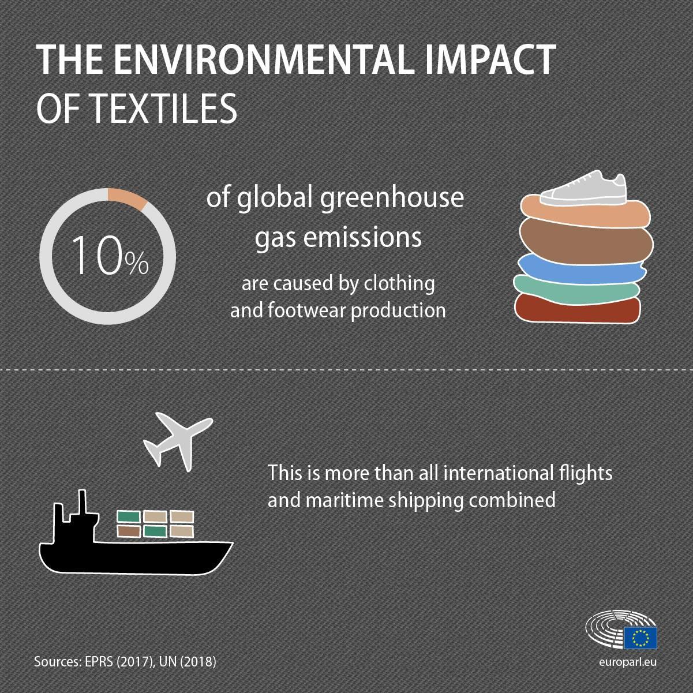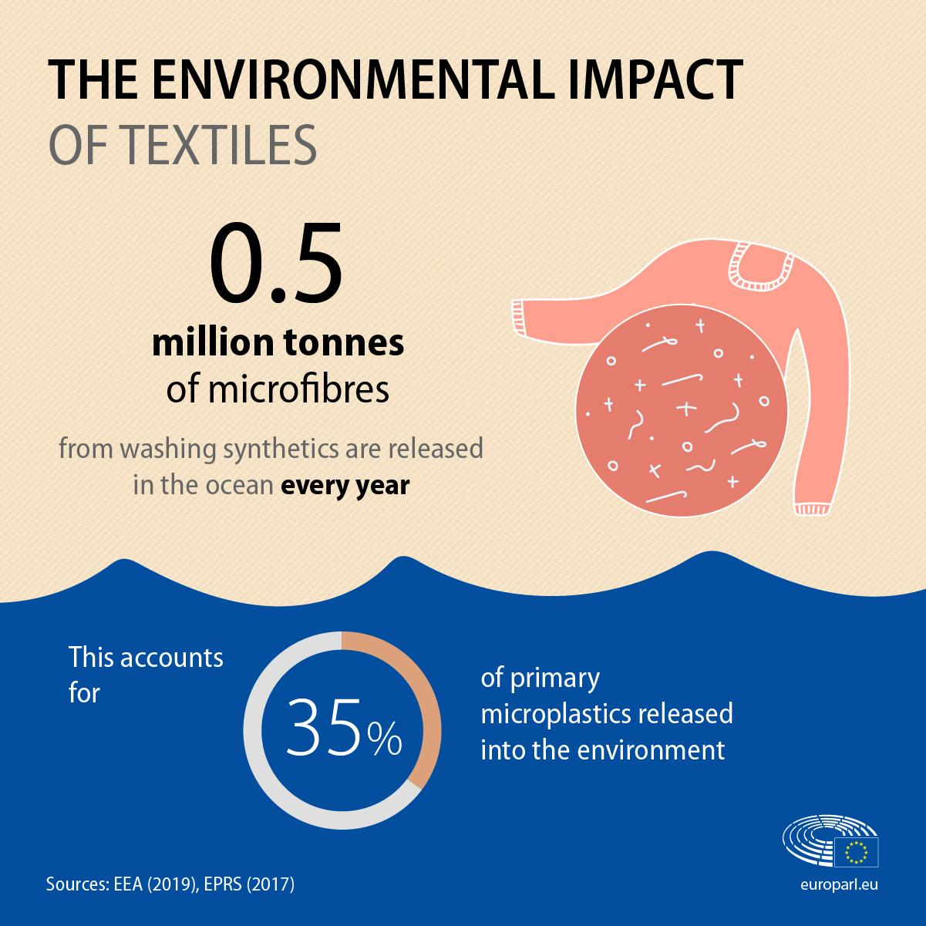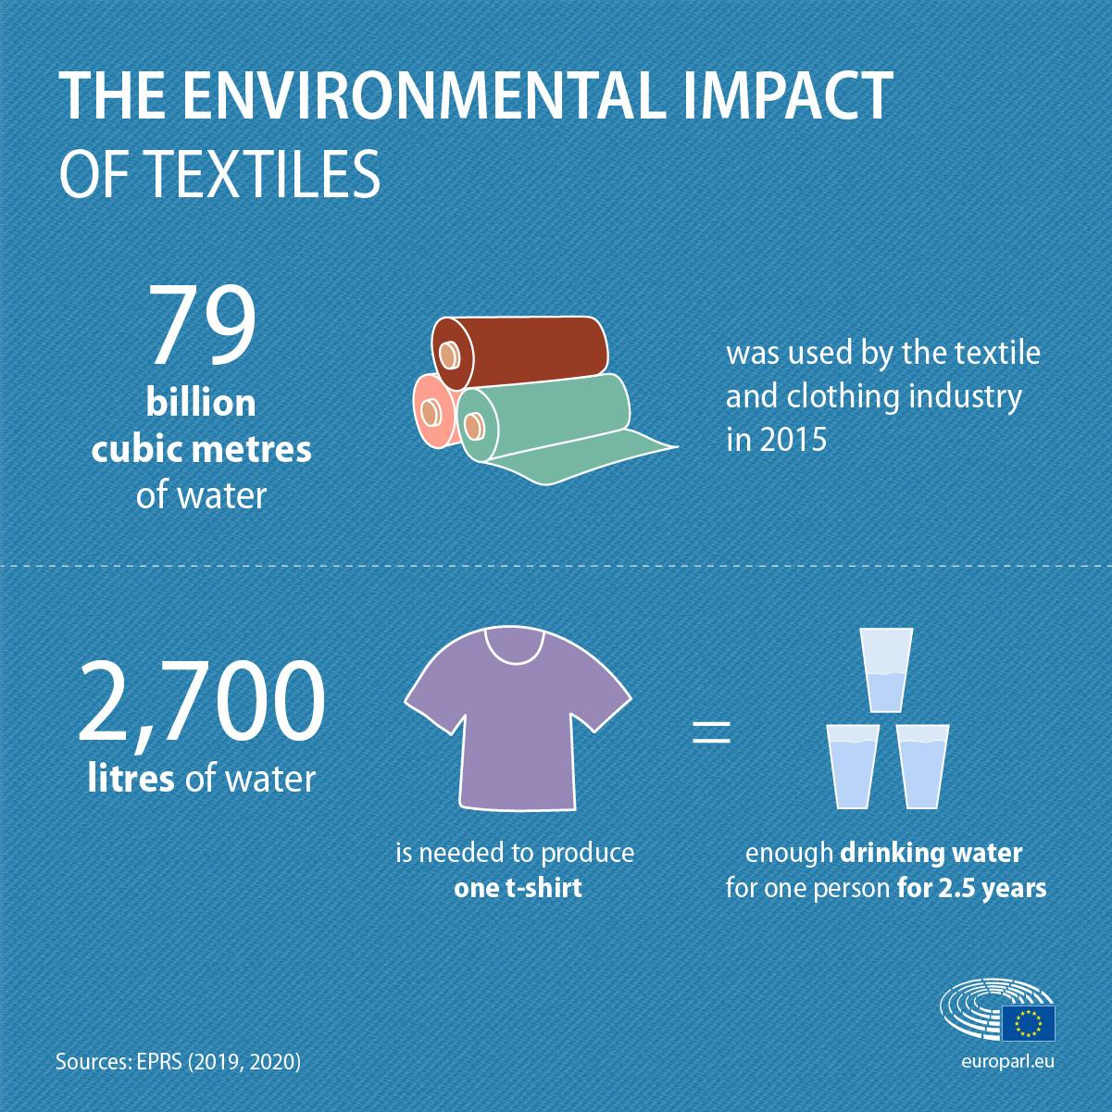

KEY CONFLICTS

Consumer preferences shape what and how fast brands produce. In this case, there are several factors which drive them away from sustainable alternatives, for example, convenience and affordability. Low prices allow for almost all consumers to afford fast fashion clothing which fuels the high demand for these products. Sustainable alternatives are often offered at a higher price-point which may not be accessible to lower socioeconomic groups.

Furthermore, there is a lack of awareness and information about sustainable alternatives whereas mainstream fast fashion brands are by no means hard to find. If consumer interest and demand for sustainable fashion would increase, these alternatives would become more popular and affordable overall.

Even though there has been a rise in the popularity of second-hand clothing, fast fashion is generating less durable garments which limits the viability of the second-hand clothing market. As more clothing that is donated and sent to be recycled comes from fast fashion brands, consumers steer away from purchasing these low-quality, used goods.

Greenwashing is when companies appear and advertise to be more sustainable than they actually are. There is no clear, quantifiable definition to terms such as “ethical” and “eco-friendly”, therefore companies have the ability to find loopholes to make false claims about green production or are purposefully vague with facts when advertising their products. Brands such as H&M have introduced ‘Conscious Collections’ through which they utilise materials made from fruit peels and leaves such as Pinatex. Even though they are advertised as ‘eco-friendly’, these materials contain plastic and petroleum-based agents which reverse any possible positive impact on the environment.

The media, in particular social media, is one of the most influential platforms for fast fashion manufacturers and retailers. Fashion and lifestyle-related content has flooded digital platforms, speeding up the rate at which fashion trends come in and out of style. Instead of designers and individual retailers setting new trends on their own through new releases, consumers are now doing this themselves and the retailers must speed up their sales to meet the demand. This new dynamic has a significant effect on how the industry operates and often results in wasted products due to the rapid turnover of collections.

KEY ACTORS

EU legislation on textiles and clothes aims to incentivise consumers to make more sustainable decisions. The European Commission legislates on naming fibres used in textiles and labelling to offer consumers protection. It is also engaged in dialogues with non-EU countries on policy and regulatory issues that affect the textiles and clothing industry. Non EU-countries, specifically countries where manufacturing of clothes is based, are particularly significant since this is where most of the environmental impacts are felt. The aforementioned environmental implications such as water and chemical pollution of soil, occur where clothes are made - outside of the EU.

Fashion retailers receive fashion products from manufacturers and sell them according to their own guidelines. They provide information about clothing to consumers such as environmental labelling (offering information on CO2 emissions, chemical and water use), as well as instructions on how to wash and dry clothing.

Member States and policy makers play key roles in advancing the environmental and social practices of the fashion industry. They are becoming more keen on advancing in environmental and social practices in regards to the fashion industry. Policy intervention can accelerate the pace at which the fashion industry is working towards better practices, for example, by applying incentives in favour of sustainability initiatives.

Non-profit organisations and media have a significant role in educating consumers on sustainability in the clothing industry. For example initiatives such the S4 Fashion: Sustainability for Fashion Industry initiative, as well as tools such as the Fashion Transparency Index or Good On you provide consumers with ratings regarding ethics and information on sustainability of products.

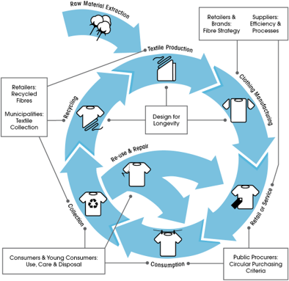
MEASURES IN PLACE

- In 2017, the European Clothing Action Plan (ECAP) was launched to improve the textile sustainability across their life-cycle from design to the end of use.

- The European Commission funded the programme and has worked with several other agencies such as fashion non-profit MADE-BY, to strengthen this initiative around Europe.

- The EU also sets European standards for textile and clothing and implements measures such as the EU ecolabel. However, as of now this certification programme is voluntary.

- The EU’s Waste Framework Directive requires Member States to set up separate collections of textiles and hazardous waste by 2025 to tackle the issue of harmful disposal.

- The EU Strategy For Sustainable Textiles will aid the EU’s shift to a climate-neutral, circular economy where products are designed to be more durable, reusable, repairable, recyclable and energy-efficient. A long term goal of these strategies is to make sustainable textiles more accessible and encourage their use in clothing production.

- The European Parliament has supported, but not fully implemented measures regarding the movement of Slow Fashion. It is typically found in small local stores instead of large enterprises like shopping malls. They release new collections two or three times a year, which means that there are limited styles to choose from. Most importantly, the garments are locally produced by high-quality sustainable materials that last a long time.

QUESTIONS TO THINK ABOUT

- Would you say that the alternatives to fast fashion have some sort of longevity? Why?
- How could alternatives to fast fashion be made affordable for customers of all economic backgrounds?
- What would be an appropriate form of cutting down clothing waste?
- What could be the further reasons people are resistant towards buying sustainable fashion?

LINKS TO FURTHER RESEARCH

Articles that may be helpful:
- https://www.politico.eu/article/pressure-grows-to-make-fashion-more-sustainable-environment-climate-change/
- http://untitled-magazine.com/how-social-media-affects-the-fast-fashion-industry/

Videos to watch:
- https://www.youtube.com/watch?v=elU32XNj8PM
- https://www.youtube.com/watch?v=5r8V4QWwxf0&t=61s

ICs

The European Youth Parliament,

- Alarmed by the overconsumption of fast fashion items around the world due to the high demand for cheap clothing,

- Noting with concern that fast fashion retailers mislead consumers on the environmental impact of their clothing through “Greenwashing”,

- Recognising the lack of accessibility to information on sustainable alternatives to fast fashion,

- Regretting that the fast fashion industry mainly uses non-biodegradable materials such as polyester which release microplastics into the environment and are major pollutants of oceans,

- Acknowledging the role social media plays in promoting the use of sustainable fashion,

- Deeply concerned that the EU mainly imports clothing rather than focusing on domestic manufacturing,

- Fully supporting initiatives such as the European Clothing Action Plan,

