Committee on Development (DEVE)
Our best shot: with vaccines providing the most promising route out of the pandemic and the threat of new vaccine-resistant variants looming with every new infection, what can the EU do to ensure even access and distribution across the globe?
Chairperson: Lucía Sancho

Introduction and Relevance of the Topic

The current coronavirus pandemic has caused more than 700.000 deaths in the EU, as of October 2021, and there have been around 237 million confirmed cases worldwide. Although there are several mass vaccination programmes, half of the population globally still has not received their vaccine dose, and 50 countries did not achieve the World Health Organisation (WHO) target (having 10% of their population fully vaccinated by the end of September).

According to the WHO, the first mass vaccination programme started in December 2020. At the moment, 13 different vaccines have been approved by the WHO, e.g. AstraZeneca, Moderna, Janssen and Sonopharm. Scientists believe vaccination to be the most efficient long-term solution to the virus. Even though the vaccine doesn't prevent the spread of the virus, it lessens the symptoms or severity of disease.

However, some of these vaccines may not protect for as long as they should, due to the many variants of the virus. Moreover, the access and distribution of vaccines among different countries is not equal as there is a large gap between the vaccinated population in Western European countries, Africa, Eastern Europe as well as several Asian areas.
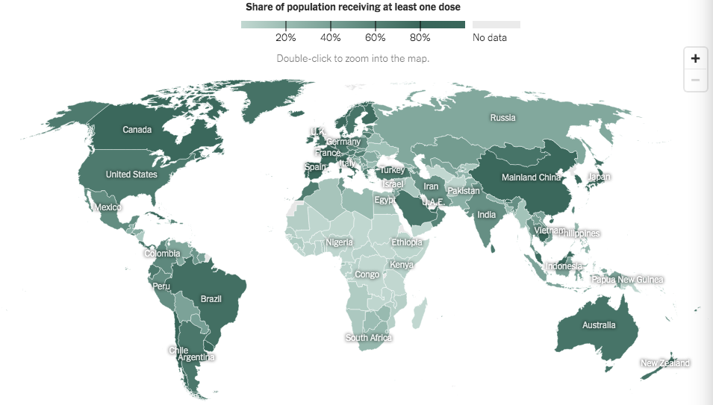
The more possibilities a virus has to spread, the more it replicates, creating more variants. Most of these mutations do not have a huge impact on the abilities of the virus. However, some Covid-19 variants have evolved into more contagious and severe viruses. Scientists now focus on a potential new threat: people who have had COVID-19 may remain susceptible to reinfection, and proven vaccines may, at some point, need an update. Due to this, global access and distribution of vaccines must be achieved as soon as possible, or else the virus will continue spreading, provoking deaths and creating dangerous variants.

Key Conflicts

More than 50 countries have missed the World Health Organization's (WHO) target for 10% of their population to be fully vaccinated against Covid-19 by the end of September. Many of these are low-income countries dealing with health infrastructure issues or suffering from conflict or civil unrest. The others have been affected by natural disasters, making the vaccine distribution process even more difficult. Some of these countries also fail to distribute the vaccine among their citizens before it expires. For instance, 24 countries, almost all of them in Africa, report using less than a third of their vaccines due to this issue. 15 of those report using less than a fourth. The reasons might be the insufficient international help to cover the logistic cost of mass vaccination and the recent news about extremely rare but potentially deadly side effects of some of the vaccines. Although research has not directly attributed any death to any of the Covid-19 vaccines, fake news has become a great barrier to global immunization and has led to anti-vaccination groups. Even in developed countries, such as the US, 33% of the population do not want the vaccine due to the misinformation that is being spread concerning its side effects.

In addition, there are several difficulties when it comes to the vaccine administration. All the vaccines carry different handling requirements, storage protocols and guidelines for thawing and timing doses. Healthcare workers need instruction about the distribution and storage of each vaccine. Many countries simply can not afford this training. With the increasing variants and mutations of COVID-19, healthcare workers will need up-to-date training for every new vaccine.

Furthermore, during the pandemic, each state, tribe and territory has developed its own process for distributing the vaccine to the citizens in their jurisdiction. Non-governmental organisations do not have the power to coordinate the distribution of the vaccines once they have arrived in the country. Although organisations such as the Center for Disease Control and Prevention (CDC) shared relevant guidance, it is up to each state to decide whether to accept it or not. Even inside of the European Union, vaccination policy is a competence of national authorities meaning the EU can only assist and recommend actions. Also, compulsory vaccination is an interference with the human right of bodily integrity, which is a part of the right to private life enshrined in the Universal Declaration of Human Rights as well as in the European Convention on Human Rights, meaning that global vaccination can only be achieved if all governments and citizens agree to it.

Lastly, even with a proper scheduling system, planning appointments for vaccination is complicated to manage, keeping in mind that vaccine shipments might not arrive or are inconsistent in some areas of the globe. Also, there is a lack of transparency about Covid-19 vaccines, which leads to corrupt networks or even stolen or diverted vaccines. These situations increase the hardships with consistent and safe distribution.

Key Actors

The World Health Organization (WHO) is an agency founded in 1948 that promotes health by keeping the world safe and serving vulnerable countries. It directs and coordinates responses to health emergencies and currently works along 194 Member States.

The European Commission (EC) ​​helps to adjust the EU's overall strategy, suggests new EU laws and policies, controls their implementation and handles the EU budget. It also plays a significant role in supporting international development and delivering aid.

The Emergency Support Instrument (ESI) is a crisis support fund that helps Member States respond to the coronavirus pandemic by addressing needs in a strategic and coordinated manner at European level. The Emergency Support Instrument is based on the principle of solidarity and pools efforts and resources to quickly address shared strategic needs. The instrument helps mitigate the immediate consequences of the pandemic and anticipate the needs related to the recovery.
Gavi, the Vaccine Alliance is an international organisation whose mission is to save and protect lives by promoting proportionate and sustainable use of vaccines. It has helped vaccinate more than 888 million children in low-income countries and has prevented around 15 million possible deaths.

The Coalition for Epidemic Preparedness Innovations (CEPI) is a global partnership that started in 2017 and aims to develop vaccines in order to enable equitable access to vaccines of infectious diseases and prevent future epidemics.

Measures in Place

- Although it is certain that there is no fair access and distribution of the vaccines around the globe, several strategies and mechanisms have been created to solve the problem. For instance, the European Commission has created the EU Vaccines Strategy in which it secures equitable and affordable access to vaccines to all Member States. It takes a common EU approach, cooperating with individual vaccine producers to buy vaccines, and financing comes from the budget of the Emergency Support Instrument.

- As for global cooperation, the European Union has contributed 1 billion euros for the COVAX Facility. Also, the Commission set up an EU vaccine sharing mechanism which allows 27 Member States to share EU purchased doses with third countries. Furthermore, on 21 May 2021 at the G20 Global Health Summit, the European Commission’s President Ursula von der Leyen announced a new initiative called Team Europe. This initiative's purpose is to help create an enabling environment for local manufacturing in Africa and tackle barriers on both supply and demand sides. It will be backed by 1 billion euros from the EU budget and other European development finance institutions such as the European Investment Bank (EIB).

- Moreover, there are many global collaborations to accelerate the development and access to COVID-19 vaccines. Two of these are The Access to COVID-19 Tools (ACT) Accelerator and the Task Force. The Task Force is a joint initiative from the International Monetary Fund (IMF), World Bank Group, World Health Organization (WHO) and World Trade Organization (WTO) aiming to accelerate access to COVID-19 vaccines by offering finance and trade solutions for low- and middle- income countries. They also met with the CEOs of leading vaccine manufacturing companies to discuss and express concerns about not reaching their target of vaccinating at least 40% of the global population by the end of 2021. They suggested distributing doses to low- and lower middle-income countries, demonstrating transparency on vaccine supply, eliminating export restrictions and prohibitions as well as regulating streamlining and harmonisation. Finally, there are other organisations and mechanisms such as the African Vaccine Acquisition Trust (AVAT) and the International Committee of the Red Cross (ICRC) that play a significant role in equal vaccine distribution.

Questions to Think About

- How can new variants of the COVID-19 virus be prevented in order to avoid the need of redistribution of new vaccines in the future?
- How can it be ensured that low-income countries use their vaccines before they expire?
- How can the EU increase equal access to vaccines outside of the European Union?
- How can healthcare workers in low- and lower middle-income countries receive the necessary training in order to efficiently store and distribute the vaccines?
- How can the EU ensure that there is enough transparency regarding the distribution and access to vaccines in all countries?

Links for further research

- Challenges of rolling out Covid-19 vaccination in low-and middle-income countries

Women in low-income countries denied access to COVID vaccines
- COVAX has so far shipped over 365 million COVID-19 vaccines

More empty promises about global COVID-19 vaccine equity

The EU promised 200M vaccine doses
- The EU's contribution to global vaccine solidarity

Global Covid-19 Vaccine Distribution Handbook
Introductory Clauses

The European Youth Parliament,

- Acknowledging the fact that more than 50 countries have missed the Global Health Organization's target for vaccination,

- Underlining the fact that 24 countries report not using in their vaccines before they expire,

- Noting with concern the high prices of the vaccines and the logistic cost of mass vaccination programs,

- Taking into consideration that vaccination policy is a competence of national authorities,

- Pointing out that healthcare workers need instruction about handling requirements, storage protocols and guidelines for thawing and timing doses for every different vaccine,

- Deeply concerned by the widely spread fake news concerning side effects of coronavirus vaccine and the anti-vaccination groups,

- Aware of the lack of transparency and the increasing corruption regarding vaccines,

- Regretting the current inconsistent distribution of vaccines around the globe,

- Expressing it's satisfaction that the European Commission has created a(n):
  - EU Vaccine Strategy ensuring access to vaccines to all Member States,
  - Vaccine sharing mechanism allowing Member States to share EU purchased doses to third countries,
  - Initiative called “Team Europe” enabling local manufacturing of the vaccines in Africa;

